We look forward to seeing you in person at IPC APEX EXPO 2022 to achieve digital transcendence!

Here are some things to keep in mind to help you prepare for your visit.

San Diego Convention Center
All events, unless otherwise noted in the printed show directory or show app, will take place at the San Diego Convention Center, 111 W. Harbor Drive, San Diego, CA.

Proof of Vaccination Status for Air Travelers to the U.S.
You must be fully vaccinated to travel to the United States by plane if you are a non-U.S. citizen, non-U.S. immigrant (not a U.S. citizen, U.S. national, lawful permanent resident, or traveling to the United States on an immigrant visa).

Are You Fully Vaccinated for Travel to the United States?
You are considered fully vaccinated:
2 weeks (14 days) after your dose of an accepted single-dose vaccine
2 weeks (14 days) after your second dose of an accepted 2-dose series
2 weeks (14 days) after you received the full series of an accepted COVID-19 vaccine (not placebo) in a clinical trial
2 weeks (14 days) after you received 2 doses of any “mix-and-match” combination of accepted COVID-19 vaccines administered at least 17 days apart

Testing Requirements for Air Travelers to the U.S.
All travelers, regardless of nationality or vaccination status, are required to show documentation of a negative viral test result taken within one day of the flight’s departure to the United States before boarding. You must show your negative result to the airline before you board your flight. That includes all travelers – U.S. citizens, lawful permanent residents (LPRs), and foreign nationals.

If you recently recovered from COVID-19, you may instead travel with documentation of recovery from COVID-19 (i.e., your positive COVID-19 viral test result on a sample taken no more than 90 days before the flight’s departure from a foreign country, and a letter from a licensed healthcare provider or a public health official stating that you were cleared to travel). For more information, please visit: COVID-19 Traveler Information (state.gov)

Onsite COVID Testing
IPC will not be offering on-site testing for those who reside outside the United States to return home, but we have compiled a list of local testing facilities within a short distance from the Convention Center which is available in the show directory.

California Department of Public Health Guidelines
Proof of full COVID vaccination or negative test (one day for antigen test and two days for PCR test) is required to gain entry to IPC APEX EXPO 2022. IPC has partnered with In-House Physicians (IHP) who will be managing the process for the pre-event clearance by verifying proof of vaccination status and negative COVID tests.

When You Should Get Tested
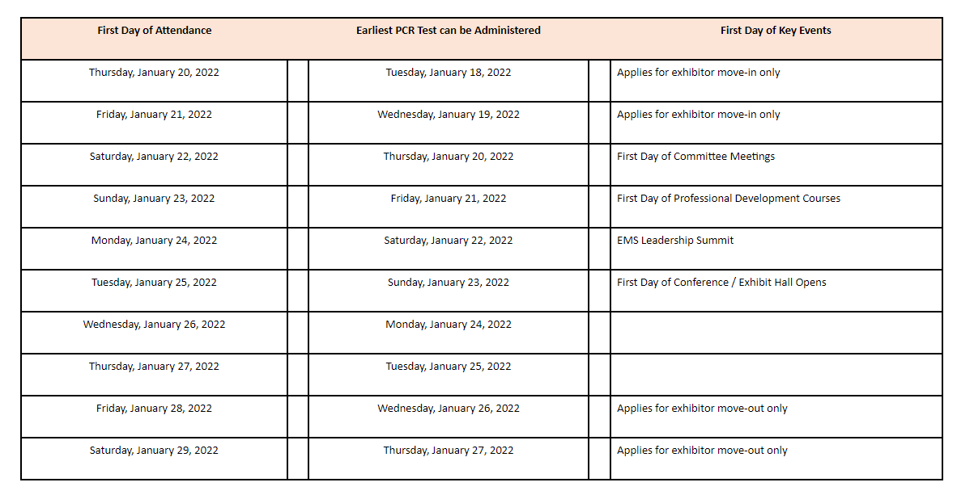

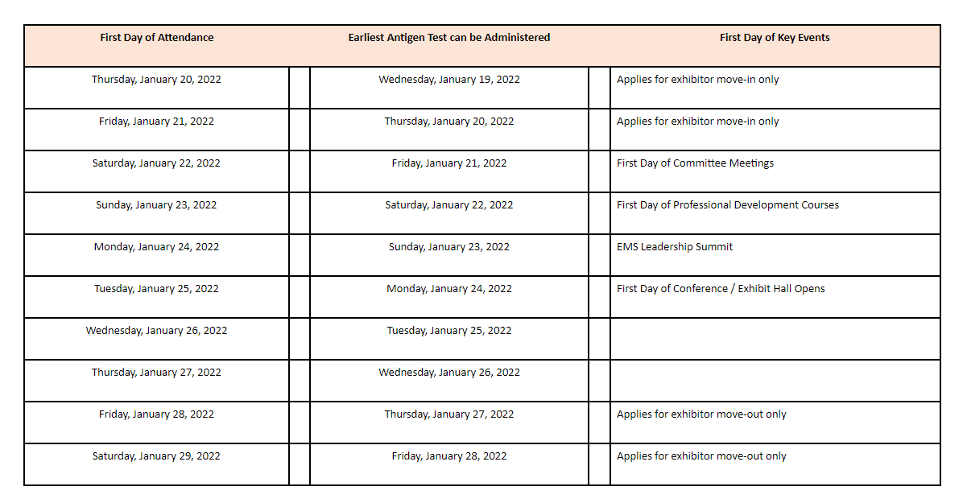

If Vaccinated - Upload Proof of Vaccination Status at: https://inhousephysicians.formstack.com/workflows/ihp_ipc_vax_v_only

Negative Test Results - Upload Negative test results to: https://inhousephysicians.formstack.com/workflows/ipc_neg_testupload

Avoid long lines onsite and upload this information in advance of your arrival at IPC APEX EXPO!
Upon Arrival at IPC APEX EXPO
All visitors must check-in at the COVID Clearance desk upon arrival to the convention center before proceeding to registration for their badge.
If you have uploaded your proof of full vaccination or negative COVID test results in advance, please retain the email from IHP confirming you’ve been cleared for entry into IPC APEX EXPO as you will be required to show this documentation along with a photo ID when you arrive at the convention center and check in at the COVID clearance desk inside Hall D Lobby, prior to proceeding to registration for your badge. Please note, this applies to your first attendance day only, which at that time, you will be given a wristband which you will be asked to wear throughout the duration of your visit to indicate you’ve been cleared for entry.
If you have NOT uploaded your proof of full vaccination or negative COVID test results in advance, please bring the appropriate documents with you as you will be required to show this documentation along with a photo ID when you arrive at the convention center and check in at the COVID clearance tent outside the Hall E lobby, prior to proceeding to registration for your badge. Please note, this applies to your first attendance day only, which at that time, you will be given a wristband which you will be asked to wear throughout the duration of your visit to indicate you’ve been cleared for entry.
Masks
In accordance with the California Department of Public Health Guidelines, masks will be required for IPC APEX EXPO, regardless of vaccination status.

Parking - On-site private vehicle parking is available at the Convention Center’s 1,950-vehicle underground garage. Parking rates are set by ACE Parking, IPC has no control over these rates which can range from $15-$35 depending on the time of year and activity taking place in the convention center. Payment is due upon entry and there are no in and out privileges. No overnight or RV parking is permitted. For additional parking near the convention center Download the SPOT HERO app and save up to 50% on parking!

Taxi Cabs - Taxi cabs are easily accessible at the Convention Center, major hotels and other downtown locations and attractions.

San Diego Trolley - MTS is a light-rail system that operates on three lines of which two are across from the Convention Center providing convenient service around downtown.

Registration
Registration is located in the lobby of Exhibit Hall D and will be open Sunday, January 23 through Wednesday, January 26 from 7:00 am–6:00 pm and on Thursday, January 27 from 7:00 am–1:00 pm.

Help Desk
A help desk is located on the upper-level lobby near the meetings area and will be open Sunday, January 23 through Wednesday, January 26 from 8:00 am–5:00 pm and on Thursday, January 27 from 8:00 am–1:00 pm.

Coat and Baggage Check
Complimentary coat and baggage check is located in Hall E lobby in front of Box Office E during show days.

Complimentary Wireless Internet Access
Complimentary Wireless Internet Access will be available in the technical conference/meetings area on the upper level of the convention center. Please note: the network is unsecured and does not use WEP encryption. Complimentary wireless internet access is not available in the exhibit halls.

Show Office – Hall D Lobby

First Aid – Hall D Lobby across from registration
In order to protect yourself and others, if you are experiencing COVID-like symptoms, please stop by the First-
Aid office for a wellness check.

Lost and Found – Show Office, Hall D Lobby

Business Center/FEDEX Office - Hall D Lobby

Food Outlets - Concessions will be open in the exhibit hall on show days.

Starbucks - Lobby area of Halls A, C and E.

Mobile Show App
Download the official IPC APEX EXPO 2022 mobile app to access and manage your schedule through the agenda planner, get the most up-to-date information on the conference and professional development courses, explore the show floor and to stay up to speed with the latest schedule updates to receive important text alerts.

Agenda Planner
Get the most out of your time at IPC APEX EXPO 2022 and make your show experience more productive and efficient than ever before with the agenda planner! It’s an easy way to schedule and keep track of your activities at the show. Update your profile in just a few minutes to see attendee matches to maximize your networking.
Log in to your personal agenda planner and start adding events, meetings, appointments along with exhibitors and products you want to see, plus much, much more.
Using the My APEX EXPO Agenda Planner you can:
- Export your planner/schedule to your calendar or use the app
- Find other attendees with similar interests
- Schedule appointments with other attendees and exhibitors
- Save time - use your personalized schedule as your trip report
- View your itinerary of free and paid activities
- View IPC APEX EXPO exhibitors
- Navigate the floor plan and plan your booth visits
- Contact exhibitors directly before the show
- Find exhibitor show specials

Event Proceedings (access available based on registration package)
- Download Event Proceedings in just four easy steps!
- Login to the 2022 APEX EXPO Agenda Planner
- Choose your TYPE under the Programs Search menu (Technical Conference, Professional Development Courses, etc.)
- Choose your registered program and/or session
- Select the material download link, click download and save the file.

Exhibit Hall Hours
Tuesday, January 25 | 10:00am–6:00pm
Wednesday, January 26 | 9:00am–6:00pm
Thursday, January 27 | 9:00am–12:00pm

Networking/Special Events
Event Awards Luncheon Registration Required
Monday, January 24 | 12:00 pm–1:30 pm | Room 6A

Newcomers Networking Reception
Monday, January 24 | 5:00 pm–6:00 pm | West Terrace

International Reception
Monday, January 24 | 5:30 pm–6:30 pm | Cityside Corridor(Upper Level)

Opening Keynote
Tuesday, January 25 | 8:30 am–9:30am | Room 6A
David Pogue, New York Times Columnist and NOVA Host
Disruptive Technology & How it Will Affect Your Business: What’s Coming by 2026

Ribbon Cutting Ceremony
Tuesday, January 25 | 9:45 am–10:00 am | Lobby D

Event Luncheon and IPC Annual Meeting Registration Required
Tuesday, January 25 | 12:00 pm – 1:30 pm | Room 6A

Show Floor Reception
Tuesday, January 25| 5:00 pm–6:00 pm | Exhibit Hall

Women in Electronics Reception at IPC APEX EXPO
Tuesday, January 25| 6:00 pm–7:30 pm | Room 6F

Wednesday Keynote
Wednesday, January 26 | 8:00 am - 9:00 am | Room 6A
John W. Mitchell, IPC President and CEO
State of the Industry: Electronics Manufacturing Embraces Digital

Ice Cream Social
Wednesday, January 26 | 2:30 pm–3:30 PM | Exhibit Hall

Trivia Networking Night Registration Required
Wednesday, January 26 | 6:00 pm–7:30 pm | Room 6D

Event Awards Luncheon Registration Required
Wednesday, January 26 | 12:00 pm–1:30 pm | Room 6A

Factory of the Future (F2 Pavilion) Booth #1701
To see how IPC’s Factory of the Future programs are solving real business challenges, by identifying new technologies that modernize industry processes. Several of these new disruptive technologies already exist such as AI-enabled inspection, AI-machine learning, CAD, 3D design, simulation, 3D printing and more. IPC connects you with these disruptive technology companies, sorts through the technologies and provides a focus for the electronics manufacturing industry.

This is also an opportunity to meet the companies that are helping to lead the electronics manufacturing industry through the next industrial revolution.

Connect with IPC!
Visit us at booth #3635 to learn how IPC standards, education and training, advocacy, and solutions can help you and your company Build Electronics Better.

Meet and Network with Poster Presenters Booth #3815
Grab a drink, lunch or an ice cream and mingle with the poster presenters the following times:
- Tuesday | January 25 | 5:00 pm-6:00pm | During the Show Floor Reception
- Wednesday | January 26 | 2:30 pm-3:30pm | During the Ice Cream Social

Design @ APEX 2022
From DFX to a showdown, Design@APEX 2022 has it all. This special area located at booth 3209 on the show floor will feature IPC’s inaugural IPC Design Competition Championship. Design Masters will be ready, willing and available to answer any burning questions regarding Design for Excellence and special DFX Spotlight Sessions will celebrate great design with the best subject matter experts the industry has to offer! We’ll end the week by passing the baton to the next generation of designers by welcoming IPC’s Education Foundation STEM program students. We welcome all designers to stop by and share their industry and career insights with our next generation of future designers!

Photography and Video Recording
Still photography and video recording of an exhibit or function is prohibited within the exhibit halls, meeting
rooms and lobbies. Show Management, the official show photographer and accredited members of the press are
exempt from this rule.

Policies
Any function that is not a part of the “official program” is prohibited, from the first meeting to the close of the
event. IPC does not permit solicitation from non-exhibiting companies. Any individual observed soliciting or selling
products to attendees or exhibitors without having a booth (known as suitcasing) will be asked to leave immediately. Please report any suitcasing activities to the IPC Show Office located in the lobby of Hall D.

For more information on IPC APEX EXPO, please visit: https://www.ipcapexexpo.org/

For the most recent updates on the California Department of Public Health safety measures, restrictions and mandates, visit: https://www.cdph.ca.gov/.

We look forward to seeing you in-person in San Diego!

